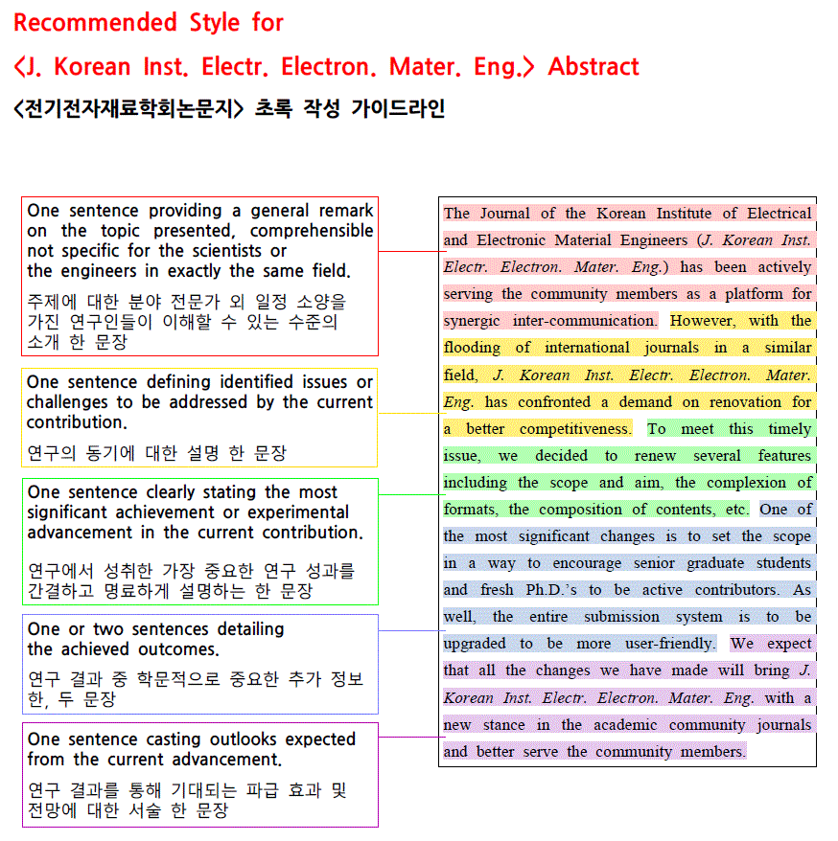

Title[영문 제목]
Author1, Author2, and Author1,2[영문 저자명]
1 Department of Materials Engineering, 00 University, City 00000[우편번호 5자리], Korea [영문 소속]
2 00 Division, Institute of 00, City 00000[우편번호 5자리], Korea [영문 소속]

Abstract: [아래의 초록 작성 가이드라인에 따라 작성해주십시오.]
One sentence providing a general remark on the topic presented, comprehensible not specific for the scientists or the engineers in exactly the same field. One sentence defining identified issues or challenges to be addressed by the current contribution. One sentence clearly stating the most significant achievement or experimental advancement in the current contribution. One or two sentences detailing the achieved outcomes. One sentence casting outlooks expected from the current advancement.

Keywords:

✉ Corresponding author Name & Email; [교신저자 이름과 메일 주소를 작성해주십시오.]
Corresponding author ORCID : [교신저자 ORCID ID를 작성해주십시오]

[Early Stage Report는 레터 형식으로 작성해주시기 바랍니다. (1장/2장/3장… 등의 섹션 구분 없이 작성)]
---내용시작---

ACKNOWLEDGEMENT

REFERENCES [DOI를 반드시 기재해주세요. ]

