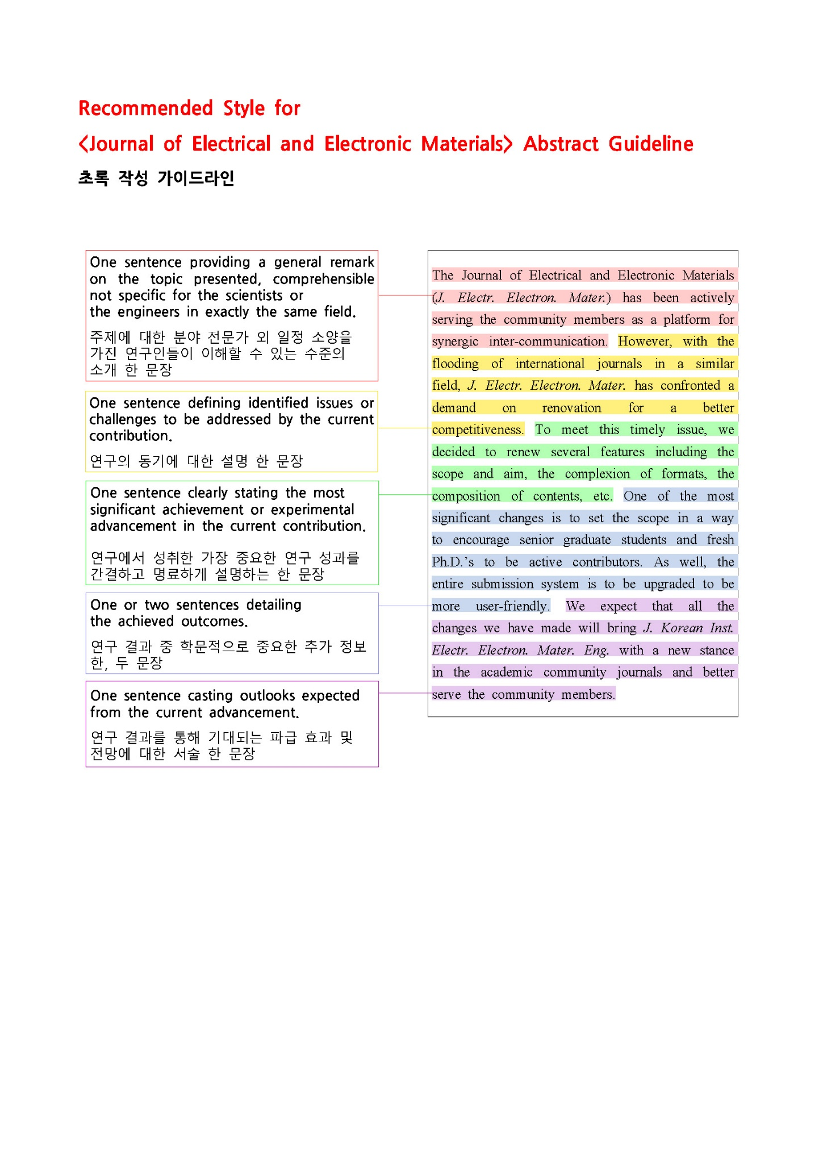

Title[국문 제목]
Author1, Author2, and Author1,2[국문 저자명]
1 00대학교 00학과 [국문 소속]
2 00연구소 00부서 [국문 소속]

Title[영문 제목]
Author1, Author2, and Author1,2[영문 저자명]
1 Department of Materials Engineering, 00 University, City 00000[우편번호 5자리], Korea [영문 소속]
2 00 Division, Institute of 00, City 00000[우편번호 5자리], Korea [영문 소속]

Abstract: [아래의 초록 작성 가이드라인에 따라 작성해주십시오.]
One sentence providing a general remark on the topic presented, comprehensible not specific for the scientists or the engineers in exactly the same field. One sentence defining identified issues or challenges to be addressed by the current contribution. One sentence clearly stating the most significant achievement or experimental advancement in the current contribution. One or two sentences detailing the achieved outcomes. One sentence casting outlooks expected from the current advancement.

Keywords:

✉ Corresponding author Name & Email; [교신저자 이름과 메일 주소를 작성해주십시오.]
Corresponding author ORCID : [교신저자 ORCID ID를 작성해주십시오]

[Early Stage Report는 레터 형식으로 작성해주시기 바랍니다. (1장/2장/3장… 등의 섹션 구분 없이 작성)]
---내용시작---

감사의 글

Conflict of Interest
Select one:
- The authors have no conflicts of interest to declare.
OR
- The author(s) (NAME) currently serves on the editorial board of JEEM, but was not involved in any part of the publication process. Other than this, the authors declare that they have no relevant potential conflicts of interest.
AND/OR
- The authors declare the following financial interests/personal relationships which may be considered as potential competing interests: company name, patent name, etc.

Author Contributions
- Select below CRediT author statement for each author:
Conceptualization, Methodology, Software, Validation, Formal analysis, Investigation,
Resources, Data Curation, Writing - Original Draft, Writing - Review & Editing,
Visualization, Supervision, Project administration, Funding acquisition
- Example:
Stephen King: Conceptualization, Validation, Formal analysis. Chang Kyu Jeong: Writing - Original Draft, Writing - Review & Editing, Visualization, Supervision, Project administration, Funding acquisition. ……

Data Availability
Select one:
-Data openly available in a public repository that issues datasets with DOIs
-Data openly available in a public repository that does not issue DOIs
-Data derived from public domain resources
-Data available within the article or its supplementary materials
-Data generated at a central, large-scale facility, available upon request
-Embargo on data due to commercial restrictions
-Data available on request due to privacy/ethical restrictions
-Data subject to third party restrictions
-Data available on request from the authors
-Data sharing not applicable – no new data generated
-Non-digital data available
-Data not available due to [ethical/legal/commercial] restrictions
-Data not available – participant consent

REFERENCES [DOI를 반드시 기재해주세요.]
- Examples (Journal, Book, Proceedings, Online document, etc)
[1] M. Shehzad, S. Wang, and Y. Wang, npj Flex. Electron., 5, 24 (2021). doi: https://doi.org/10.1038/s41528-021-00121-z
[2] H. Ibach and H. Lüth, Solid-State Physics, 2nd edn. (Springer, Dordrecht, 1996), pp. 45–56.
[3] T. K. Ha and Y. W. Chang, Proc. 2nd Pacific Rim Int. Conf. on Adv. Mater. & Processing (eds. K. S. Shin, J. K. Yoon, and S. J. Kim) (Korean Inst. Metals & Mater., Gyongju, Korea, 1995) p. 253.
[4] J. Cartwright, Big stars have weather too. (IOP Publishing PhysicsWeb, 2007),
http://physicsweb.org/articles/news/11/6/16/1. Accessed 26 June 2007

